# Report 3

**team members：**

白明松 16301059

**technical features applied：**

Use Case Scenario:

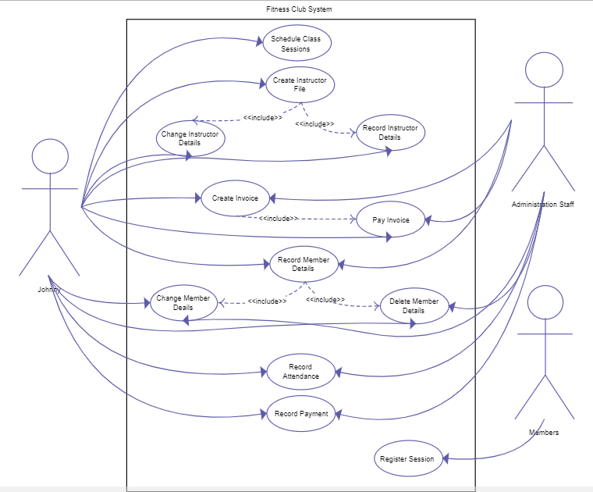

1, As a gym club app user, he/she can watch the training video online. Primary needs for this function include a video list where each video item consists of a picture as well as short explanation and/or may be click through rate, and a video player that can be opened by click each video item on list.

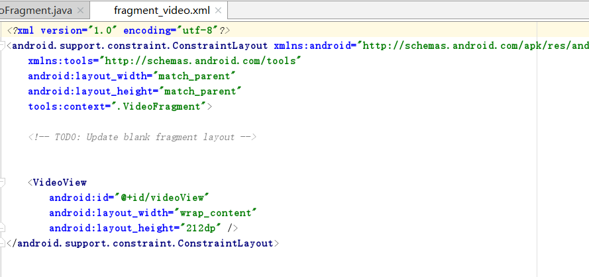

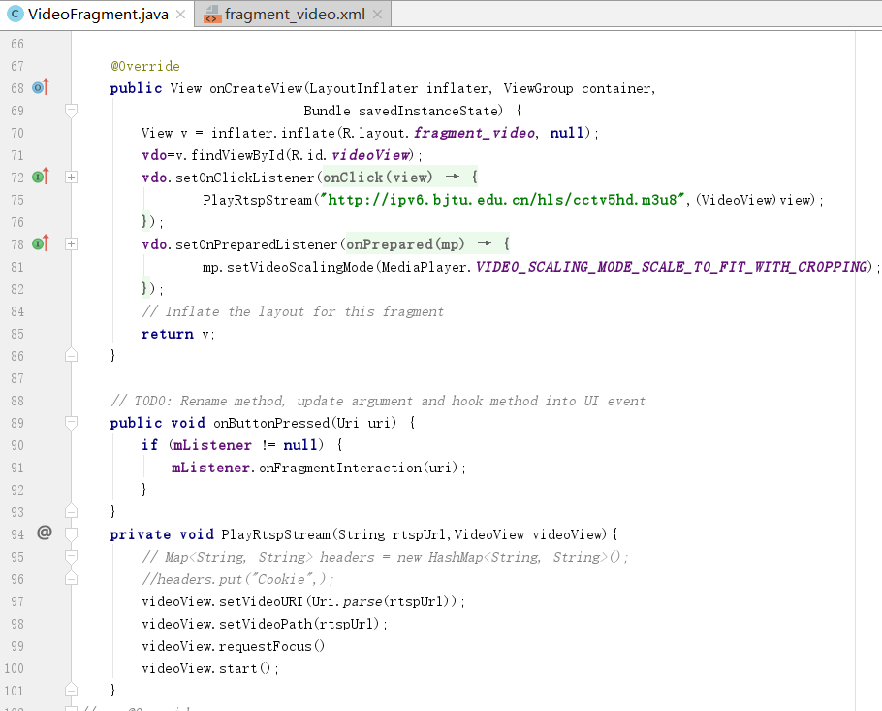

2,As an app user, when he/she is browsing the private trainer list, he/she may want to send a email or leave a SMS message or take a call according to the contacts provided in the list.

